Department | AIDS
Course Code / Course Name | DSA0602/ Data Handling and Visualization
Experiment | Data Visualization using R
Name | Ayesha Siddiqa S
Register Number | 192324305
Date | 20/10/2026
Day | Tuesday
SET 26

Experiment 1: Math histogram and Science boxplot by gender
Aim: To inspect the distribution of Math_Score and compare Science_Score across genders.
Algorithm: Import or create the data; draw a histogram of Math_Score and a gender-grouped boxplot of Science_Score; label both plots.
R Program:
library(ggplot2)
students <- data.frame(
Student_ID = c("S01","S02","S03","S04","S05","S06"),
Gender = c("Male","Female","Male","Female","Male","Female"),
Study_Hours = c(2.0,3.5,1.5,4.0,2.8,3.0),
Attendance = c(78,90,70,95,85,92),
Math_Score = c(62,80,55,90,72,82),
Science_Score = c(65,85,58,92,74,86),
Exam_Date = as.Date(c("2025-01-10","2025-01-10","2025-02-12",
"2025-02-12","2025-03-15","2025-03-15"))
)
ggplot(students, aes(Math_Score)) +
geom_histogram(binwidth = 10, fill = "skyblue", color = "black",
boundary = 0) +
labs(title = "Distribution of Math Scores",
x = "Math Score", y = "Number of Students") +
theme_minimal()
ggplot(students, aes(Gender, Science_Score, fill = Gender)) +
geom_boxplot() +
labs(title = "Science Scores by Gender",
x = "Gender", y = "Science Score") +
theme_minimal() + theme(legend.position = "none")
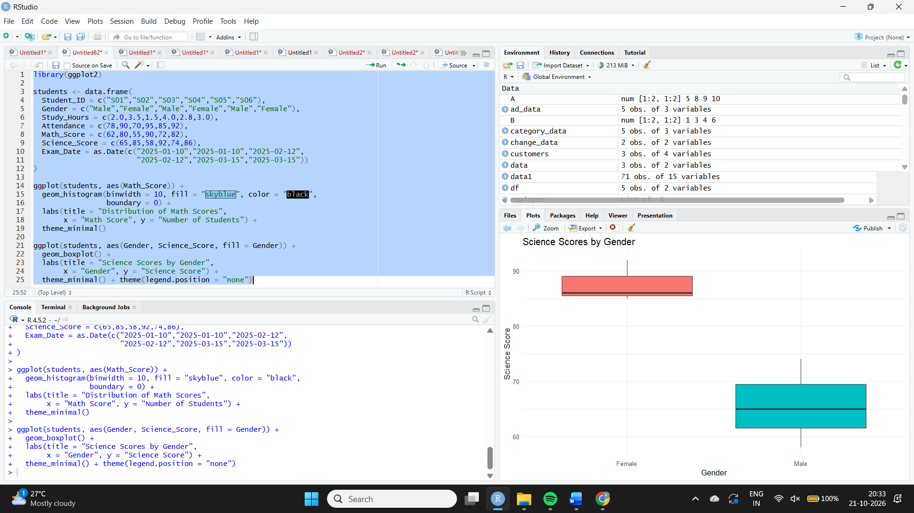
Result / Interpretation: In this small sample, female students have higher Math and Science scores on average. The sample is too small to generalize to a wider student population.
Experiment 2: Study hours versus Math score
Aim: To explore the relationship between study hours and Math scores by gender.
Algorithm: Plot Study_Hours on x and Math_Score on y; color points by Gender; add a linear regression line.
R Program:
library(ggplot2)
students <- data.frame(
Gender = c("Male","Female","Male","Female","Male","Female"),
Study_Hours = c(2.0,3.5,1.5,4.0,2.8,3.0),
Math_Score = c(62,80,55,90,72,82)
)
ggplot(students, aes(Study_Hours, Math_Score, color = Gender)) +
geom_point(size = 3) +
geom_smooth(method = "lm", se = FALSE, color = "black") +
labs(title = "Study Hours vs Math Score",
x = "Study Hours", y = "Math Score") +
theme_minimal()
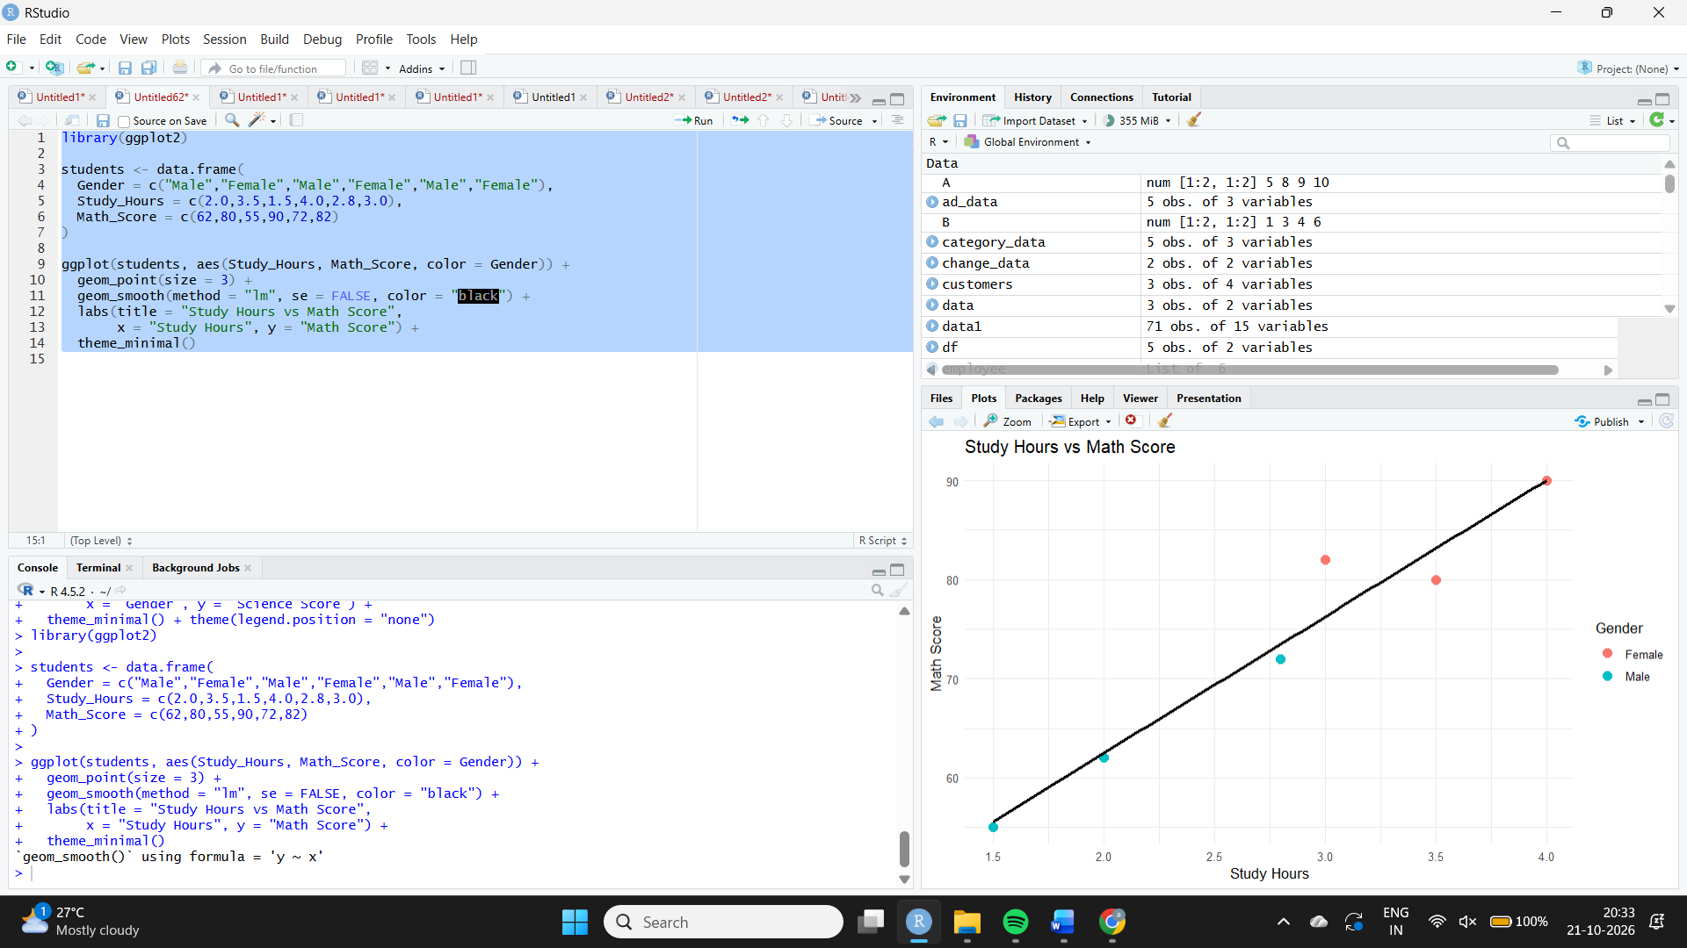
Expected output: A scatter plot with a fitted linear regression line.
Result / Interpretation: The points show a generally positive association: students who study more tend to have higher Math scores in this sample. Six observations are not enough to establish causation.
Experiment 3: Monthly average Math score and moving average
Aim: To convert Exam_Date to Date format, calculate monthly average Math scores and plot a smoothed trend.
Algorithm: Convert Exam_Date to Date; group observations by month; calculate means; apply a moving average; plot monthly values and smoothing.
R Program:
library(ggplot2)
library(dplyr)
library(zoo)
students <- data.frame(
Math_Score = c(62,80,55,90,72,82),
Exam_Date = as.Date(c("2025-01-10","2025-01-10","2025-02-12",
"2025-02-12","2025-03-15","2025-03-15"))
)
monthly <- students %>%
mutate(Month = as.Date(format(Exam_Date, "%Y-%m-01"))) %>%
group_by(Month) %>%
summarise(Avg_Math = mean(Math_Score), .groups = "drop") %>%
arrange(Month)
monthly$Moving_Avg <- zoo::rollmean(monthly$Avg_Math,
k = 2, fill = NA, align = "right")
print(monthly)
ggplot(monthly, aes(Month, Avg_Math)) +
geom_line(color = "steelblue", linewidth = 1) +
geom_point(size = 3, color = "steelblue") +
geom_line(aes(y = Moving_Avg), color = "red",
linewidth = 1, na.rm = TRUE) +
labs(title = "Monthly Average Math Score with Moving Average",
x = "Exam Month", y = "Average Math Score") +
theme_minimal()
Expected output: Monthly averages: January = 71, February = 72.5, March = 77. The two-month moving average for February is 71.75 and for March is 74.75.
Result / Interpretation: Average Math scores increase from January through March. The two-month moving average also rises, indicating an upward trend in this sample.
Experiment 4: Student dashboard in Tableau
Aim: To compare average Math scores by gender and display score trends over time with a date filter.
Algorithm: Import Student_Mini_Data.csv; build gender bar chart and date line chart; add Exam_Date filter; place worksheets on a dashboard.
Procedure (Tableau): Connect to Student_Mini_Data.csv. For the bar chart, put Gender on Columns and AVG(Math_Score) on Rows. For the trend chart, put Exam_Date (month or exact date) on Columns and AVG(Math_Score) on Rows; choose Line. Show an Exam_Date filter and apply it to relevant worksheets. Combine the worksheets into a dashboard.
Result / Interpretation: The supplied sample shows average Math scores of 63 for males and 84 for females. Monthly averages rise from 71 in January to 77 in March.

